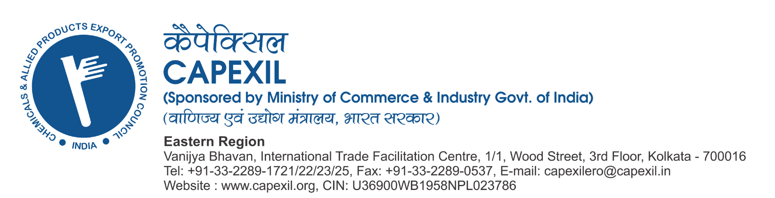

================================================================================================

Dear Sirs,

**Subject: Virtual Awareness / Training Programme on "Maximizing benefits through best utilization of Trade Agreements / FTAs" for Ceramic Products including recently concluded FTA between India & UK on 29th July, 2025 (Tomorrow) from 09.45 am to 01.30 pm.**

**Warm Greetings from CAPEXIL....**

We are pleased to announce a **Virtual Awareness / Training Programme on "Maximizing benefits through best utilization of Trade Agreements / FTAs" for Ceramic Products** **including recently concluded FTA between India & UK to be organized by CAPEXIL on 29th July, 2025 (Tomorrow) from 9:45am to 1:30pm.**

**Topic:** **"Maximizing benefits through best utilization of Trade Agreements / FTAs" for Ceramic Products** **including recently concluded FTA between India & UK.**  
   
Sh. Sudhakar Kasture Founder and Mentor of EXIM Institute, who have trained over 6,000 professionals in Foreign Trade Policy, Customs Regulations, Free Trade Agreements (FTAs), WTO guidelines, SEZ regulations, and ESG compliance will address the participants, share insights, and resolve exporters’ queries in real time.  
   
**The objective of this program is to enhance the overseas footprint, increase market access, reduce trade barriers, strategic planning and explore new markets for the Exporters from the Indian Ceramic Industry / Ceramic Panel of CAPEXIL through best utilization of Trade Agreements / FTAs are in place. Also to make aware the Industry about specific documentation required towards getting the benefits of Trade Agreements.**

**Please find below the details:**

**Meeting link:**

[**https://capexil.webex.com/capexil/j.php?MTID=m1adcfabb2e33d477cafd050d5e0347f3**](https://capexil.webex.com/capexil/j.php?MTID=m1adcfabb2e33d477cafd050d5e0347f3)

**Meeting number: 2516 408 0826**

**Password: 12345**

**Host key: 831957**

**Programme Details:  Date:** **Tuesday, 29th July 2025 (Tomorrow)**

**Venue: CISCO WEBEX Virtual Platform**

**TIMINGS: 09.45 am to 01.30 pm (including Q and A)  
09:45 am to 10:10 am : Joining to the Event / Registration  
10:10 am to 10:15 am : Welcome Address  
10:15 am to 11:30 am : 1st Session  
11:30 am to 11:45 am : Break / Presentation by Sponsor  
11:45 am to 01:00 pm : 2nd Session  
01:00 pm to 01.20 pm : Q and A noon  
01:20 pm to 01:30 pm : Vote of Thanks**

Join by video system

Dial [25164080826@capexil.webex.com](mailto:25164080826@capexil.webex.com)

You can also dial 210.4.202.4 and enter your meeting number.

Join by phone

65-6703-6949 Singapore Toll

Access code: 2516 408 0826

Host PIN: 2365

**Agenda:**

**Areas to be covered:**

**1)    Basics of FTAs :**  
a)    Emergence of FTAs  b) Understanding of PTA/FTA/ CECA/CEPA/Customs Union  
   
2)     **Tariff Schedules**  
a)    How to read Tariff Schedules under Free Trade Agreements b) Introduction to Basics c) Examples of India-ASEAN FTA, India-EFTA TEPA, India-UAE CEPA, etc.  
   
**3)    Rules of Origin**  
a)    Understanding basics of Rules of Origin b) Demystify Terminology c) WO (Wholly Obtained), CC (Change in Chapter)/CTH (Change in Tariff Heading)/CTSH (Change in Tariff Sub-Heading) RVC (Regional Value Content)/ VA (Value Addition) c) Formulas to compute value addition criteria in Product Specific Rules d) How to obtain “Certificate of Origin”  
   
**4)    How to leverage India’s FTAs to boost exports to partner countries**  
   
**5)    PESTEL Analysis and Importance of landed cost to improve global footprint - Export of Ceramic & Allied Products**

**In view of the above, we humbly request your gracious presence and active participation in the event and also pass on this information to your fellow industry colleagues for their awareness and active participation.**

**We urge all Indian Exporters to take advantage of this golden opportunity to gain valuable insights on the subject matter.**  
   
For any queries, please feel free to contact:  Kuntal Ghosh, Executive Officer, CAPEXIL, KOLKATA  
“Vanijya Bhavan”1/1, Wood Street, Kolkata – 700 016. Email: [eoero@capexil.in](mailto:eoero@capexil.in), Mob.: 91 9674992355 (Call & WhatsApp)

Looking forward to your active participation to make this event a grand success.

Best regards,

SD/-

(Samir Kumar Ghosh)

Chairman - Ceramics & Allied Products Incl. Refractories Panel,

CAPEXIL