 *** COUNTRY PROFILE - EGYPT
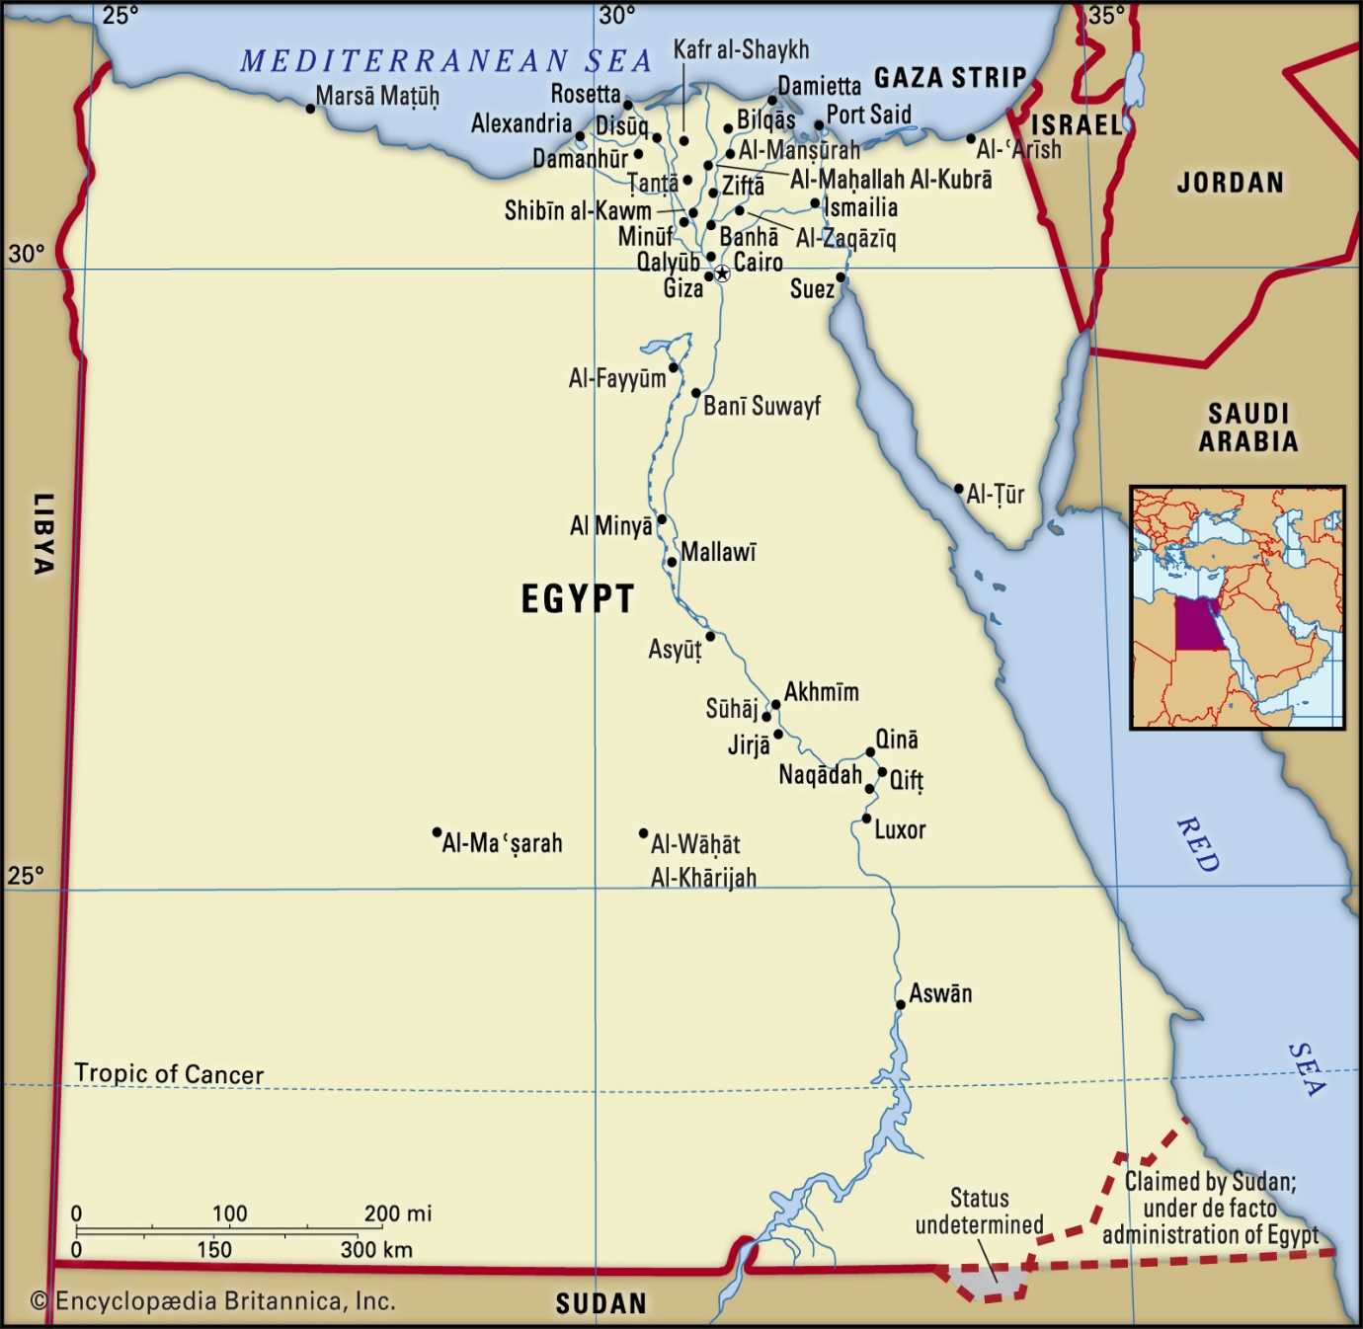
Prepared by:
Commerce Wing – Embassy of India, Egypt

- General Information
Capital | Cairo
Area | 1,001,450 sq km
Population | 106.500 million (2nd July 2024)
Currency  Exchange rate with US$ & INR | Egyptian Pound;  Exchange Rate: 48.30 Egyptian Pound= 1 USD (As on 2nd July 2024) Exchange Rate to INR: 1 EGP = 1.73 INR (2nd July 2024).

- Economic Profile:
 | GDP, PPP (current international $) | US $ 1.67 Trillion (2022-2023)
 | GDP (official exchange rate) | US $ 476.75 Billion (2022-2023)
 | GDP - real growth rate | 6.6% (F.Y. 2022-23) (July-June)
 | GDP - per capita (PPP) | US $ 4295.4 (F.Y. 2022-23) (July-June)
 | Per Capita Income | US $ 4,585.331 (June 2022).
 | GDP - Composition, by sector of origin
 | Agriculture | 11.57% of GDP
 | Industry | 32.01% of GDP
 | Services | 51.76 %
 | Major Agricultural products | Cotton, Fresh fruits, Vegetables etc.
 | Major Industrial products | Textiles and refined petroleum.
 | Industrial production growth rate | 8.8 % (Dec 2022).
 | Unemployment rate | 7.1 % (Q3 of 2023).
 | Inflation rate (consumer prices) | 29.310% (June 2024).
 | Population below poverty line | 29.7% (Nov 2021).
Source: World Bank, CBE of Egypt.

- Comparative Indicators

Index | India | Egypt
HDI (UNDP) | 0.633 (132nd) | 0.73 (97th)
GCI (WEF) | 61.4 (68th) | 54.5 (93th)
LPI (World Bank) | 3.14 (44th) | 2.82 (67th)
*Source: UNDP, WEF & World Bank,2022
- Indian Community in Egypt

Egypt has diaspora of only around 3600 Indians who are mainly employed in service sector, manufacturing and high-level management in the Multinational corporation MNCs.

- Trade Profile:
- Egypt Merchandise Trade with World (Apr23- June24); (Data is available till March 2024 on CAPMAS)
 | Exports | US $ 41.14 billion
 | Imports | US $ 81.56 billion
 | Trade | US$ 122.70 billion.
 | Trade/GDP Ratio | 25.7 %
*Source: Egyptian Central Agency for Public Mobilization and Statistics
CAPMAS

- Trade dependency of Egypt of Top economies of the world (Apr23 – June24): (Data is available till March 2024 on CAPMAS)
 | China | US$ 12.50 billion (15.27 % of total imports)
 | KSA | US$ 5.50 billion (6.72 % of total imports)
 | USA | US$ 5.20 billion (6.35 % of total imports)
 | Russia | US$ 4.80 billion (5.87 % of total imports)
 | Germany | US$ 4.10 billion (4.96 % of total imports)
 | Italy | US$ 3.20 billion (3.93 % of total imports)
 | India | US$ 2.90 billion (3.54 % of total imports)

*Source: CAPMAS

- Egypt Top Export Destinations (Apr 23 - June24): (Data is available till March 2024 on CAPMAS)
1. | Turkey | US$ 3.14 billion (7.63 % of total exports)
2. | Italy | US$ 3.10 billion (7.5 % of total exports)
3. | KSA | US$ 2.90 billion (7.07 % of total exports)
4. | UAE | US$ 2.20 billion (5.37 % of total exports)
5. | USA | US$ 2.10 billion (5.08 % of total exports)
6. | Libya | US$ 2.00 billion (4.77 % of total exports)
7. | Spain | US$ 1.7 billion (4.10 % of total exports)
8. | Greece | US$ 1.40 billion (3.41 % of total exports)
9. | United Kingdom | US$ 1.30 billion (3.07 % of total exports)
10. | India | US$ 1.00 billion (2.51 % of total exports)

- India’s share is US$ 1 billion (2.51% of total exports). (10th Rank).

- Egypt Top Import Sources (Apr 23 – June24): (Data is available till March 2024 on CAPMAS)
1 | China | US$ 12.50 billion (15.27 % of total imports)
2 | KSA | US$ 5.50 billion (6.72 % of total imports)
3 | USA | US$ 5.20 billion (6.35 % of total imports)
4 | Russia | US$ 4.80 billion (5.87 % of total imports)
5 | Germany | US$ 4.10 billion (4.96 % of total imports)
6 | Italy | US$ 3.20 billion (3.93 % of total imports)
7 | India | US$ 2.90 billion (3.54 % of total imports)

- Trading Partner India’s share is 3.54 % (7th Rank).

*Source: CAPMAS

- Membership in FTA’s
- Pan Arab Free Trade Agreement/ Greater Arab Free Trade Agreement (GAFTA)
- Common Market for Eastern and Southern Africa (COMESA)
- Agadir Free Trade Agreement
- Egypt-EU Association Agreement
- Egypt-EFTA Free Trade Agreement
- Qualified Industrial Zones (QIZ)
- Egypt Turkey Free Trade Agreement
- Egypt-MERCOSUR Free Trade Agreement
*Source: Egyptian Ministry of Trade and Industry

- Bilateral Trade: (Data is available till March 2024 on CAPMAS)
- Merchandise trade- India’s total merchandise trade with Egypt was US $ 3.420 Bn in (Apr 23 - June 24). India registered a merchandise trade surplus of US$ 1.516 Billion.
 | Exports (Apr 23 – June 24) | US$ 2.5 billion
 | Imports (Apr 23 - June 24) | US$ 952.3 million
 | Trade Surplus (Apr 23 - June 24) | US$ 1.52 Billion.
(CAPMAS)
Merchandise Trade Data (Value: USD millions)
Year | Exports | Imports | Total Trade | Trade Balance | %Growth
 |  |  |  |  | Exports | Imports
2018-19 | 2,886 | 1,677 | 4,564 | 1,208 | 20.65 | 29.77
2019-20 | 2,504 | 2,031 | 4,535 | 472 | -13.24 | 21.07
2020-21 | 2,264 | 1,892 | 4,156 | 371 | -9.58 | -6.84
2021-22 | 3740 | 3520 | 7260 | 220 | 65%  (YoY) | 92%  (YoY)
Source: DGCIS

- Top 5 Principal commodities of exports (Apr 23 – June 24) (Data is available till March 2024 on CAPMAS)
Petroleum Products, Meat, Ferro-Alloys and rice.
HS  Code | Commodity | (Apr 23- June 24)– (US $)
2023 | Cuts of bov, boneless, frozen | 541,056,104
2710 | 95 octane gasoline output from the process of refining crude oil or crude oils obtained from bituminous minerals materials | 271,550,000
1006 | Semi-milled or wholly milled rice, whether or not polished or glazed | 100,040,487
7202 | Ferro-silico-manganese | 83,267,617
8445 | Textile spinning machines | 68,213,744

- Top 5 Principal commodities of imports (Apr 23 – June 24) (Data is available till March 2024 on CAPMAS)
Crude, Natural Gas, Fertilizers and phosphates.
HS  Code | Commodity | (Apr 23- June 24)– (US $)
2709 | Petroleum, crude | 444,144,900
2510 | Natural calcium phosphates, unground | 112,242,427
5201 | Other cotton, not carded or combed, ginned | 110,050,592
2711 | Liquefied natural gas | 76,660,000
3102 | Urea, whether or not in aqueous solution | 40,505,368

- Products with good potential for export from India

Pharmaceuticals, Automobile and auto components, IT and IT enabled services, railways, construction, Renewable energy, desalination, Infrastructure, data centers, etc.

- Services trade- India’s total services trade with Egypt was US$ 237 million in 2021-22. India registered a service trade surplus of US$ 216 million. (No recent data)
 | Exports (2021-22) | US$ 226.7 million
 | Imports (2021-22) | US$ 10.3 million
 | Trade surplus (2021-22) | US$ 216.4 million
Source: CAPMAS
- Service Trade Data
(Value: USD Million)
Year | Exports | Imports | Total Trade | Trade Balance | %Growth
 |  |  |  |  | Exports | Imports
2018-19 | 248.2 | 1.03 | 249.2 | 247.17 | -15 | 27.3
2019-20 | 205.79 | 1.41 | 207.2 | 204.38 | -17.1 % | 36.8
2020-21 | 186.78 | 0.4 | 187.2 | 186.38 | -9.23 % | -71.6
2021-22 | 226.7 | 10.3 | 237 | 216.4 | 21.3 | 2400
Source: CAPMAS

- Top sectors of services Export:
Machinery Software (79%)
Pharmaceutical services (18.1%)

- Top sectors of services Import:
Pharmaceutical services (90.2%)
Machinery Software (5.8%)

- Potential Services exports from India to Egypt
Telecommunication and Computer Services
Education-related Services
Fin-tech

- Market Access Issues:
Market access for Indian Cotton, Date palm & Coconut seedlings are explained in point No. 8
- Non-Tariff Barriers:
Sr | Issue | Action Taken | Feedback/Reciprocal Measures
1 | Export of Raw Cotton from India to Egypt | Export of raw cotton to Egypt from India is currently banned due to phytosanitary concerns. During the JWG on Trade and Investment between India and Egypt on 03rd March 2021, the Egyptian side stated they will have to visit India to complete the Pest Risk Analysis (PRA) exercise. | Egyptian visits to India for inspection are awaited  There is a need to expedite the inspection of cotton facilities by Egyptian inspectors at the earliest.
2 | Export of Date Palm Seedlings from India to Egypt | Date Palm Seedlings export is banned from India due to phytosanitary concerns. The Egyptian side stated they will have to visit India to complete the Pest Risk Analysis (PRA) exercise. | Egyptian visits to India for inspection are awaited  There is a need to expedite the inspection of Indian facilities by Egyptian inspectors at the earliest.
3 | Certificate and Registration of Indian drugs | Exclusion from list of reference countries: Although Indian companies have more advanced certifications than US and EU regulators; Egypt continues to rely on the old GMP certification. This adverse regulatory environment is one reason why India is excluded from the list of 22 reference countries used by Egypt’s Ministry of Health. | The 1st JWG on Drugs and Pharmaceuticals was held on 14th March, 2022.  Egyptian Drug Authority and CDSCO need to coordinate at institution level to include India in the list of 22 reference countries.
4 | Export of coconut Seedlings from India to Egypt | Coconut Seedlings export is banned from India due to phytosanitary concerns. The Egyptian side stated they will have to visit India to complete the Pest Risk Analysis (PRA) exercise. | Egyptian visits to India for inspection are awaited  There is a need to expedite the inspection of Indian facilities by Egyptian inspectors at the earliest.

- Institutional basis for engagement (in brief)
- 5th India-Egypt Joint Trade Committee met in Cairo on 25 Jul 2022, in background of highest ever bilateral trade figures of US$ 7.26 bn in 2021-22. The meeting was chaired by Dr Srikar Reddy, Joint Secretary Ministry of Commerce and Industry and Mr Yahya El Wathik Bellah, Head, Egyptian Commercial Service.
- The 5th Egypt-India Joint Business Council JBC meeting was held in Cairo on 26 Jul 2022, after 6 years. The meeting was attended by FICCI delegation of businessmen representing sectors like chemicals, IT, manufacturing, 2-wheelers etc and business leaders of Egyptian companies.
- JWG – There are four JWGs currently between India and Egypt. The last JWG in Trade and Investment was held in March 2021. Steps to expedite convening the JWGs on Agriculture, Plant and Animal Quarantine (to be taken by Deptt. of Agriculture Cooperation & Farmers Welfare, Deptt. of Animal Husbandry, Dairying & Fisheries and APEDA) and Industrial Cooperation, SMEs and IT (to be taken by Deptt. of Industrial Policy and Promotion, M/O Micro, Small & Medium Enterprises, National Small Industries Corporation (NSIC), Deptt. of Electronics & Information Technology) to take the discussions with the Egyptian side forward in these sectors, which may enhance our exports and help remove non-tariff barriers.
- 01st JWG on Drugs and Pharmaceuticals was held on 14th March, 2022. Indian delegation headed by Dr. Sumit Garg, Deputy Secretary Department of Pharmaceuticals.
- 01st JWG on Health and Medicine was held on 11thApril 2022 between
Ministry of Health and Family Welfare, Government of India and Egyptian Ministry of Health and Population.
- 01st JWG on Animal Husbandry, Dairies and Fisheries was held (Virtually) on 25th October 2022 between Ministry of Fisheries, Animal Husbandry and Dairying, Government of India & Ministry of Agriculture and Reclamation, Government of Arab Republic of Egypt.

- Trade Disputes of Egypt with India (In brief, with present status)
The Ministry of Trade and Industry in Egypt has imposed anti-dumping duties on imports of iron alloys (ferrosilicon) from China, India and Russia, for a period of 5 years, starting from 01 April 2021. 15% anti-dumping duties were imposed on the Indian products. The details of the investigation report by the Egyptian side were shared by the Mission to Department of Commerce on 13th April 2021.
- Investment Details:
- Cumulative FDI inflows into India (from Apr 2000 to March 2022): US$ 847,400 million
(Including equity, re-invested earnings & other capital)
- Cumulative FDI equity inflows (remittance-wise)
- Share of Egypt in FDI Equity Inflows (from Apr 2000 to March 2022)
1. | Rank | 89th
2. | Percentage share of total FDI inflows | 0.0
3. | Total FDI Inflows from Egypt | US$ 10.39 million (Rs.66.2 Crores)

*Source: DPIIT
- Indian FDI
Egyptian Investment Relation with Egypt,

Egyptian Investment in India | US$ 37 million
Indian Investment in Egypt | US$ 3.70 billion

As per the Embassy record, Egyptian companies have invested nearly US$ 37 million. (We understand that some of the investments are routed through some third countries)

- Firms operating
- Indian firms operating in Egypt:

- TCI Sanmar, Birla Carbon, Indorama Dhunseri, Embee International Industries, Flex P Films (Egypt) S.A.E, Velocity Group of Companies, Galaxy Chemicals (Egypt) SAE, Misr Hytech Seed International, Dabur Egypt Limited, Pharmed Healthcare, Sun Pharma Egypt, Lulu Group of Companies, EKC Egypt, Platinum Stabilizers Egypt and ABDOS FMCG etc.

- Egyptian companies operating in India:

El Sewedy group, KAPCI Coatings and Modern Waterproofing Group (Bitumode) and 700 Apps.

- Strategic economic relationship
During this period of 2022-23, the top Indian imports from Egypt were Mineral Oil/Petroleum, Fertilizers, Inorganic Chemicals and Cotton and main items of export to Egypt from India were Buffalo Meat, Iron & Steel, Light Vehicles and Cotton Yarn. In 2023 according to the Egyptian Central Agency for Public Mobilization and Statistics (CAPMAS), India is 9th largest export market for Egypt, India is the 9th Largest Trading partner to Egypt with US 3.926 total trade (Apr 23 - June 23) and 7th largest exporter to Egypt.

- Defence Cooperation between India and Egypt
Lately there has been a significant increase in traction in Defense cooperation. Focused approach has led to gaining momentum and enhanced military engagement with the Egyptian Armed Forces. Other than subscribing to training courses like DSSC, NDC, NDA (new) and reciprocal delegation visits, Egyptian Military has increased its engagements highlighting the importance being accorded to the mutual relationship. First Joint Tactical Air Exercise involving fighter aircraft was conducted in Egypt from 29-31 Oct 2021. In addition, a Joint Special Forces Exercise, earlier planned in Jodhpur in May 21 is now planned in Jan 2022. Further, there is ever increasing transit traffic of Indian Air Force and Indian Naval aircraft through Egypt; in addition to the Suez Canal traffic and port visits by Indian Naval Ships. It is worthwhile to mention that all Indian military aircraft proceeding to North America, Europe or Russia, transit via Egypt. Same is the case for Egyptian Naval hospitality for Indian Naval ships during the frequent Suez Canal crossings and Port Calls along the Red & Mediterranean Seas. It is also pertinent to highlight that two Port Calls by our frontline stealth frigate, INS Tabar, just 03 months apart (27-28 Jun & 03-05 Sep 2021) demonstrate increase in operational engagements in all three dimensions.

14. Indian COVID-19 Vaccine Recognition status
Covishield produced by SII, India is recognized by the Egyptian Ministry of Health and Population. The process of mutual recognition of vaccine certificates are underway.
15. Details of recent Bilateral Exchanges of India with Egypt
12 Indian delegations participating at the Egyptian fairs as follows:
Sl. No. | Name of Exhibition | Date | Details of delegation
1 | Africa Food Manufacturing Exhibition | 2-4 August, 2021 | 6 Indian companies in the field of food processing and manufacturing participated in the event
2 | Paper Middle East Exhibition PAPER ME | 4-6 September, 2021 | FIEO led a delegation of 27 companies in the field of paper manufacturing and paper technology
3 | BSM on India-Egypt Food Processing and Packaging Technology | 19-21 September, 2021 | 15 companies led by TPCI organized the BSM in Cairo.
4 | Cairo Fashion & Tex Exhibition | 23-25 September, 2021 | Wool & Woollens Export Promotion Council led a delegation of 21 companies
5 | PHARMACONEX Exhibition | 3-6 October, 2021 | Pharmexcil led a delegation comprising of 26 Indian companies.
6 | Mac Tech | 9-12 December 2021 | EEPC lead a 20 Indian companies’ delegation.
7 | Food Africa | 12-15 December 2021 | 15 Indian companies participated in the event.
8 | Cairo International Fashion and Textile Expo | 2-4 March 2022 | TEXPROCIL lead a 15 Indian companies’ delegation.
9 | Egypt Projects Exhibition | 17-19 March, 2022 | CII headed a 35 Indian companies’ delegation.
10 | Africa Health ExCon | 5-7 June 2022 | Pharmexcil headed a 26 Indian companies’ delegation.
11 | Pharmaconex | 4-6 Sept, 2022 | 46 Indian companies participated in the event.
12 | PAPER Middle East (ME) | 3-5 Sept, 2022 | FIEO headed a 30 member Indian companies’ delegation.
13 | Cairo Fashion and Tex exhibition | 6-8 Oct, 2022 | TEXPROCIL and PDEXCIL headed a 29-member delegation.
14. | Egypt Energy Exhibition | 30 Oct-2 Nov 2022 | 16 Indian companies participated.
15. | Food Africa Egypt | 5-7 December 2022 | 20 Indian companies participated including from Dairy sector.
16. | India Africa Business Summit | 22-23 January 2023 | More than 30 Indian Services Sector company led by SEPC visited Cairo for B2B meetings.
17. | Services Exports Promotion council Delegation | 20-23 Jan, 2023 | More than 20 Indian Companies services sector companies participated
18. | EGYPSYS 2023 | 12-14 Feb, 2023 | 10 Indian Companies participated
19. | Fi Africa and Pro Pak | 28-30 May, 2023 | More than 17 Indian companies were exhibiting.
20. | Africa Health Ex Con | 6-9 June, 2023 | More than 23 Indian companies were exhibiting
21. | Agro Egypt | 9-12 July,2023 | 4 Indian companies attended the Event and business meetings.
22. | Seamless North Africa | 17-18 July, 2023 | NPCI attended the event and had meetings with CBE, EBC and other payments stakeholders in Egypt.
23. | Paper Middle East Exhibition PAPER ME | 2nd September, 2023 | Ambassador inaugurated the Exhibition with the participation of 30 FIEO and Indian companies
24. | Metal and Steel Exhibition | 2nd September, 2023 | Ambassador inaugurated the Exhibition with the participation of 22 Indian companies
25. | Pharmaconex | 3rd September, 2023 | Ambassador inaugurated the Exhibition with the participation of 65 Indian companies
26. | Sahara Exhibition | 10th-12th September, 2023 | The commercial wing participated and interacted with the (7) Indian exhibitors at the exhibition.
27. | Hydrogen Egypt Summit | 13th September, 2023 | Ambassador participated in a panel about the future of Green Hydrogen
28. | CII Delegation | 3-5 October 2023 | Around 17 Members of CII had meetings and interacted with the Egyptian Government
29. | India Real State Event (CREDAI NATCON Sharm El Sheikh) | 5-6 October 2023, 2023 | Ambassador and Egyptian PM participated along with Members of CII, Indian businessmen and 1350 Indians Came in the event.
30. | Food Africa | 13 December 2023, 2023 | Minister of Supply & Internal Trade H.E. Mr. Ali Moselhi inaugurated India Pavilion at #foodafricacairo on 12 December 2023. More than 40 Indian companies displayed various products including #Basmati Rice, Spices, Tea & Processed Food.
31. | EGYPES | 19-21 February 2024 | Around 12 companies participated in the event as exhibitors
32. | Cafex | 18th April 2024 | Featuring more than 120 key exhibitors covering the full spectrum of the Hospitality.
33. | Waterex | 28th April 2024 | Around 3 companies participated in the event as exhibitors  The Watrex Expo is a significant international trade fair for water and wastewater technology

Annex
- Ongoing Bilateral Trade Issues (in brief)
India’s Concerns
Issues | Status
Inclusion of India in the 22 Reference countries in Pharmaceuticals. | The issue was discussed in the last JWG on Pharmaceuticals held in March 2022. There needs to be institution level dialogue mechanism between Egyptian Drug Authority and CDSCO in order to include India in the list of 22 reference countries, which was last updated in 2009.
PRA exercises for Date palm seedlings, coconut seedlings and cotton. | Visit by Egyptian inspectors to Indian facilities is pending.

Egypt Concerns
Issues | Status
Export of Pomegranate from Egypt to India | Egypt shared technical information on Egyptian pomegranate in September 2020.  The Indian Ministry of Agriculture shared the Pest Risk Analysis PRA report on 14th August and mission shared it with the Egyptian side and awaiting for the feedback.

Major Issues pointed out by EOI/HCI
Issues | Status
Registration of Indian labs with NFSA (National Food Safety Authority.) | Indian labs if registered with NFSA can overcome issues of residual pesticides content because of which there are issues of inspection of Indian consignments at ports. This has affected tea, spices, rice, etc.

